CLAMAGERAN-FOIREXPO - WORLDWIDE OFFICIAL FREIGHT FORWARDER - ON SITE HANDLING CONTRACTOR

SHIPPING GUIDELINE

- VENUE – LE CORUM

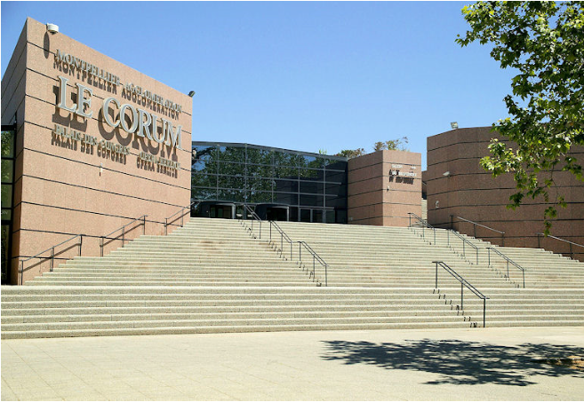
Le Corum Palais des Congrès - Opéra Berlioz
Esplanade Charles De Gaulle
34000 Montpellier

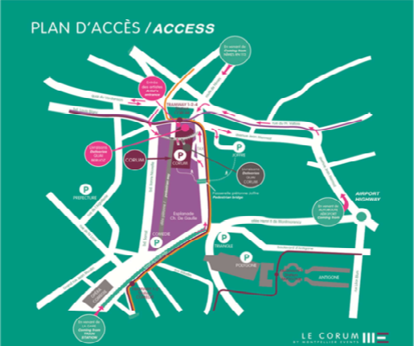
How to access :
By road
A9 motorway : Exit no. 29 - Montpellier Est, 10 minutes from Le Corum A75 motorway by Clermont-Ferrand
By plane
Montpellier- Méditerranée International Airport, 8 Km from Le Corum
By train
SNCF Rail station 5 minutes from Le Corum
Pedestrian access during the congress
LE CORUM – Palais des Congrès South entrance Esplanade Charles de Gaulle 34000 Montpellier
Exhibitor access (build-up and break-down only)
LE CORUM – Palais des Congrès Unloading platform Le tunnel du Corum - Rue de Sully 34000 MONTPELLIER -

- EXHIBITION SCHEDULE
Build up : May 23-24 Breakdown: May 27 from 7:00pm
The exhibition will take place level 0 ( groundfloor) of LE CORUM
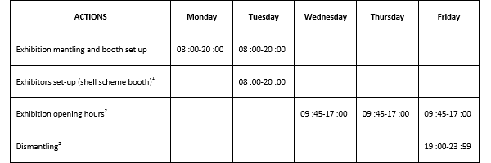

SHIPPING INSTRUCTIONS

Please address your inquiries, information to the attention of :

CLAMAGERAN FOIREXPO
Tél : +33 (0) 1 57 25 18 77
Fax : +33 1 45 30 28 81
Email : French-riviera@clamageran.fr
Ctc : Paola BURLANDO

Deliveries and relevant deadlines :

- Arrival deadline at Marseille seaport / Marseille airport / Montpellier warehouse :

- Seafreight:
For LCL shipments : May 8th , 2016
For FCL shipments : May 15th , 2016

- Airfreight : with arrival at Marseille airport : May 15th ,2016

- Roadfreight at our Montpellier advanced warehouse for goods free of customs :
May 19th , 2016

- Documentation:

1) Shipment pre-alert: required by fax or by email
Copy of necessary documents prior to the arrival of the vessel/ aircraft (B/L or Airway bill, commercial invoice, packing list indication of Hall/ stand no.)
If the goods are under ATA carnet, a copy of the carnet is requested together with a letter of authorisation (power of attorney) if our company is not mention in the document.
Letter of representation for customs clearance: signed and stamped by the shipper or agent.
Requested delivery date/time to the booth and contact details of person on site.

2) Original documents :
For B/L ( if original requested), the original documents need to be received by us no later than 10 days prior the vessel/ aircraft arrival.
ATA carnet -Original certificates of Sanitary-Veterinary, certificate of origin; etc….) upon request

Note: Please follow the deadlines carefully, as we will not assume the consequences for a late arrival of the shipment.

Instructions for filling out documents: (B/L or MAWB/ Commercial invoice and packing list)

- Bill of lading for arrival at Marseille / Fos-sur mer port OR Masterairwaybill for arrival at
Marseille airport :
CONSIGNEE:
Clamageran Foirexpo
Parc des Expositions
Porte de Versailles
75015 Paris
Contact : Paola BURLANDO
Tél : +33 (0) 1 57 25 18 77 – Fax : +33 1 45 30 28 81 Email : French-riviera@clamageran.fr
Notify party :
exhibition name : ISTH 2016
Exhibitor name / hall and stand no.:

2) For Commercial invoice / Packing list :
CONSIGNEE:
Exhibiting company name :
ISTH 2016
Hall / stand no :
Le Corum Palais des Congrès
Esplanade Charles De Gaulle

34000 Montpellier . France

Notify party : Clamageran-Foirexpo

Customs formalities

CLAMAGERAN FOIREXPO can handle the following type of customs formalities on behalf of the exhibitor :
- Transit documents
- Temporary import customs formalities
- ATA carnet - Re-exportation or permanent entry after exhibition.

IMPORTANT NOTICE

All invoices and certificates of origin must be filled with the name of the exhibitor or importer.
Please note that Clamageran should not be named as buyer/exhibitor or as consignee of the goods since we are just a freight forwarding company, not an exhibitor or an importer.
All the shipments without a full compliance of our instructions might be held at the Airport or at the seaport; in any case, Clamageran will decline any responsibility.

Please find, hereafter, the new customs procedure regarding temporary admissions for conferences and exhibitions:
A - For shipment under temporary import we strongly recommend you to move the shipment
under ATA Carnet
B- Without ATA Carnet
In order to obtain the customs regime of temporary admission, in exemption of customs duties and taxes, for equipment and demonstration booth, exhibitors participating in the conferences and exhibitions have to :
1) provide the following documents:
Extract from the commercial register proving the legal existence of the company requesting the temporary admission.
Articles of Association, mentioning the name of the authorized person to sign on behalf of the company requesting the temporary admission.
Copy of the identity document of the authorized person to sign on behalf of the company.
Power of Attorney stamped and signed, mandating the customs agent to complete customs formalities.

EORI number, delivered in one of the 28 countries of the European Union.
2) specify the following information:
Place of the accounts (city and address).
Brand of computer software used for accounting.
Nature, quantity and value of the equipment for which is requested the temporary admission.
These administrative procedures, which must be submitted to the Direction Régionale des Douanes in Montpellier, are time consuming.
That is why we ask all exhibitors to provide all documents and information requested 3 weeks before the conference or exhibition.
Last-minute request will not obtain any authorization of temporary admission, and, consequently, goods and equipment will not be delivered on booth.

Packing material:
All wooden packing materials entering one of the EU ports will need to be in conformity with the international phyto-sanitary standard ISPM-15. Only wood, free of bark; correctly treated and showing the IPPC stamp will be accepted.

Labelling :
The following marking must be clearly stated on at least two sides of each case/crate/pallet :
Exhibition name :
Hall/ Stand no.:
Case no.:
Weight/ Dimension: (optional but preferable)
For fragile goods, please mark the ’up –right position’ outside the box.

Insurance
Clamageran Foirexpo is not responsible for any loss, pilferage or damage whilst goods are left unattended on your stand. We will endeavour to deliver/ collect your goods to/ from your stand when requested, however this cannot be guaranteed. We therefore strongly recommend that
your shipment is fully insured for all risks to include transit to and from the exhibition and also during build-up, open period and break-down with your own insurance company.

Instructions of the exhibits after exhibition:

If we did not receive the instructions from agents / partners in advance, our staff will visit the exhibitors during the exhibition for return shipping instructions and will provide them with return labels.
a) Declaration of contents in each package must be correct as per invoice.
b) Shipment declared under temporary import must return as per inbound. For additional items, we will clear a separate customs for re-export.
c) Outbound movements
1. For return shipment to a different destination, this must be collected and stored in our bonded warehouse in order to cancel first the temporary import bond and issue a transit document before shipping.
2. For items cleared under permanent entry, please note that they must be collected and stored in our warehouse at the end of the show. Once the customs formalities have been completed and the duty & tax have been paid, we will release them to the final consignee.
The failure in following the above may imply a customs penalty, which will be on exhibitor’s own cost.

